**Raw Database**

**Sales table consists of**

* Customers
* Date
* Markets
* Products
* Transactions

**Transactions Table :**

**Problems in the database :**

Sales amount is -1 and currency = “USD”.

Total entry in sales Transactions Table : 1,50,283.

Total Entry in the customers table : 38 count

**Markets Table :**

**Problems:**Zone Missing In last 2 enteries.

Overall Transactions done in Chennai _ having market_code = “Mark001”.

Count total number of entries in Chennai :

To check the transactions based on the year and date – using inner join   
Select sales.transactions.* , sales.date.*

From sales.transactions

Inner Join sales.date

ON sales.transactions.order_date = sales.date.date;

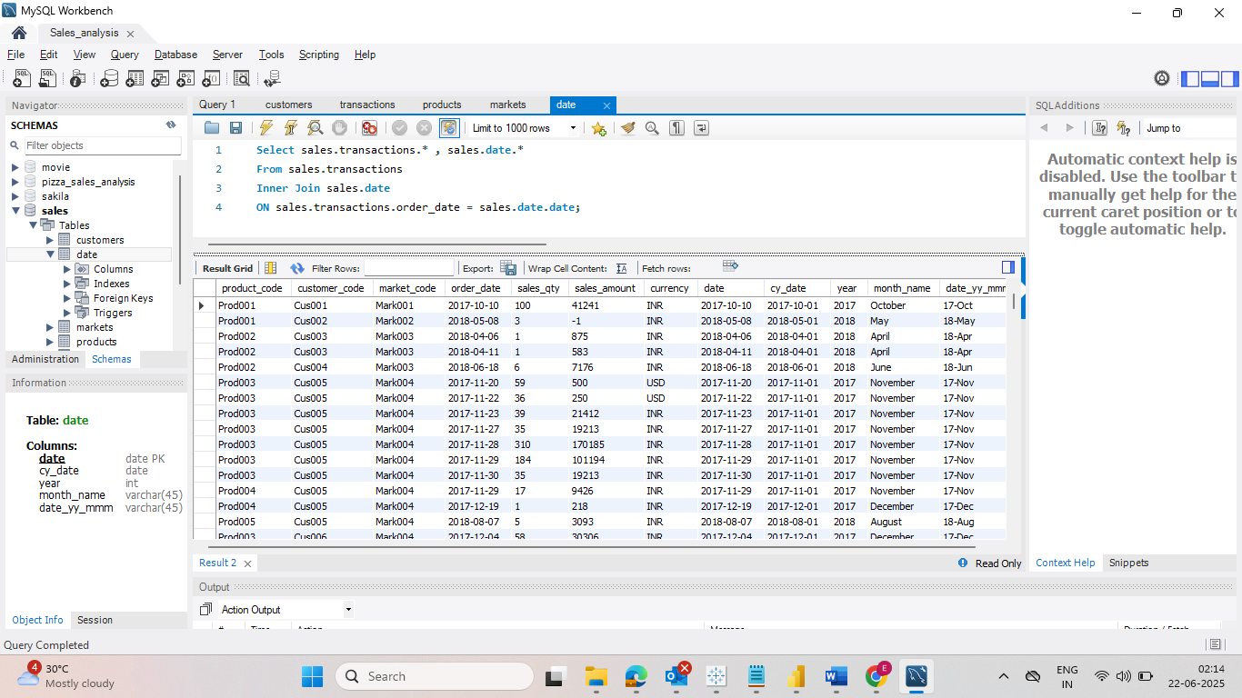

Where year = “2020”.

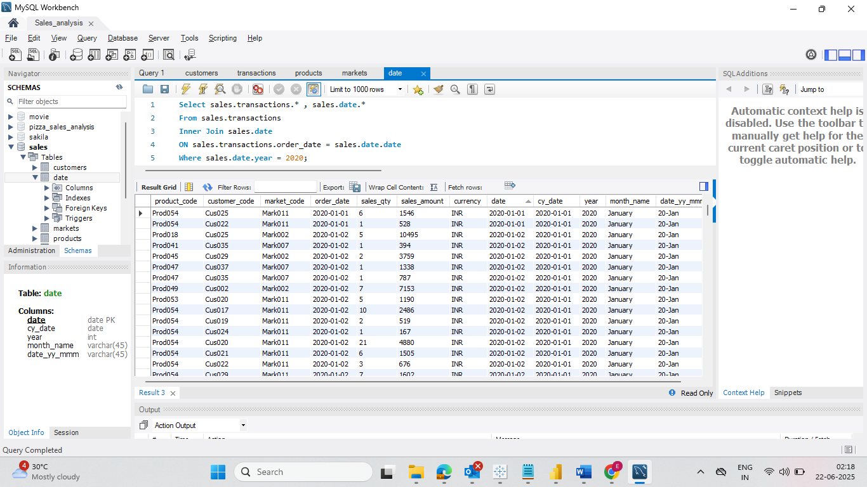

* Finding the total revenue for the year 2020.

Sales revenue for the year 2019

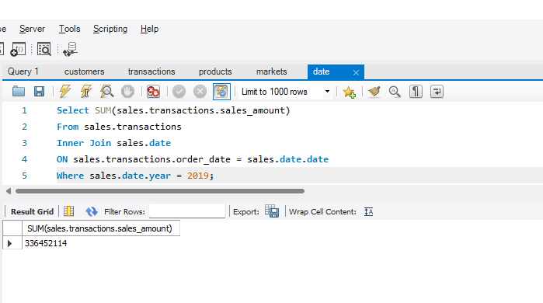

* Declining in the amount of the revenue compared to the last year

Understanding the total revenue for the year = 2020 and zone = “Chennai “ Using market_Code = “Mark001”.

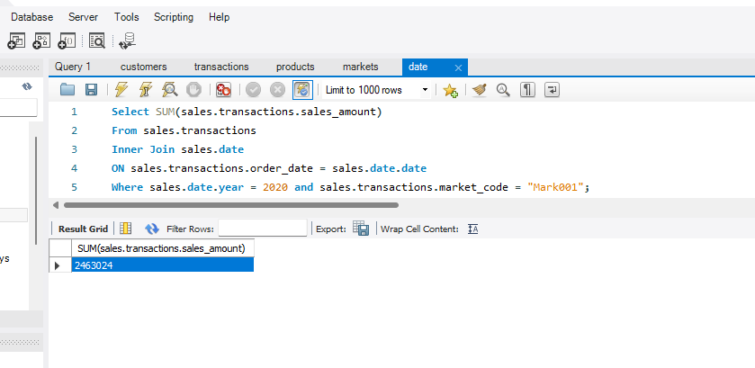

Select Distinct Product_code from Transactions Table where Market_code = “mark001”

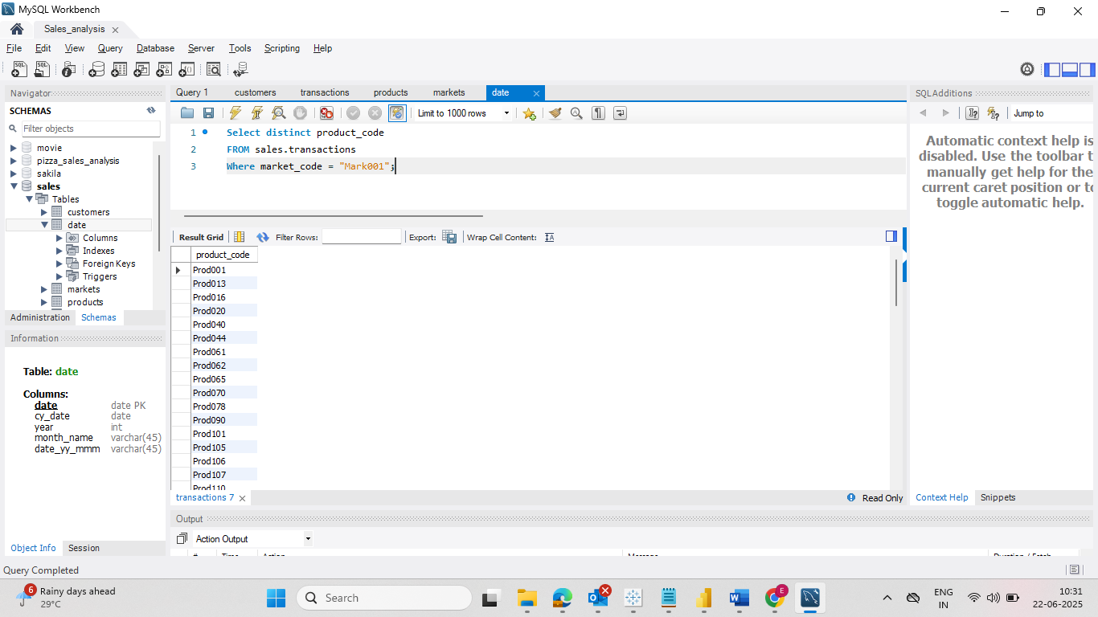

2. Import to PowerBi

Star Schema – {sales Date and sales market were not connected with the schema.}

1. Removing Blank spaces from the market table.

1. After removing blank spaces from the market table.

1. Next working on sales Transactions ,through sql checking that amount <= 0

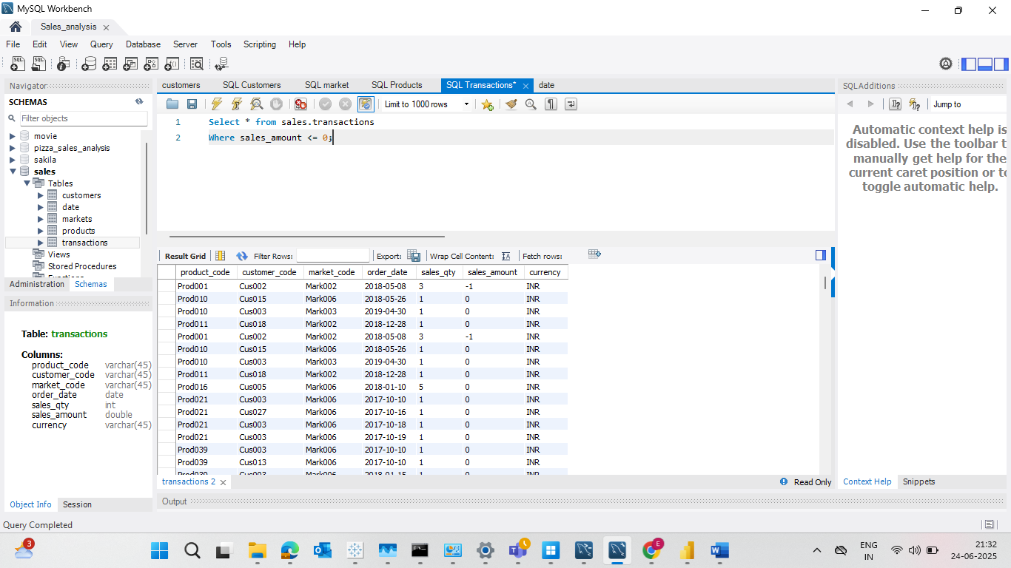

1. Apply conditional formatting column to filter and transform USD data into INR currency.

(v) Transformed the currency from “USD” into ‘INR’ using conditional column.

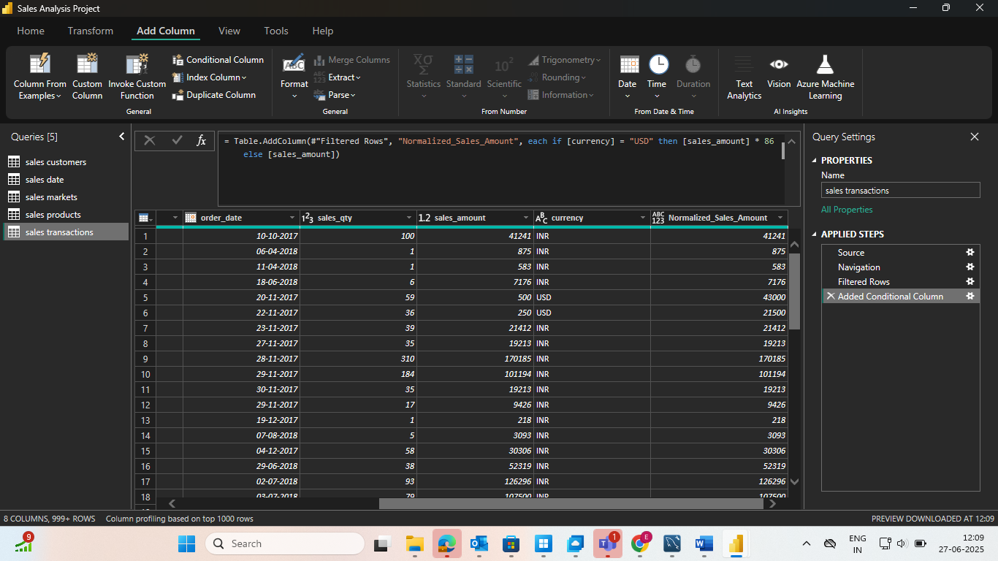

(vi) While Cleaning the data in currency duplicates field are shown.

(vii) Problem : There are two types of currency which are formed due to which the transformation has not been applied.

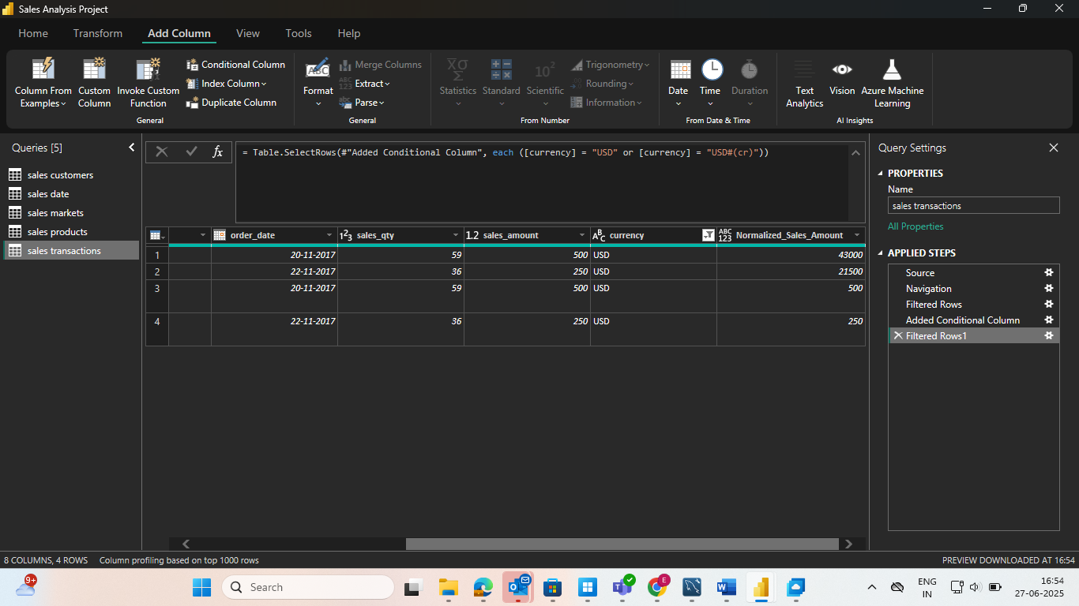

(vii) After applying the conditional formatting based on the formulas :

(viii) The changes are applied successfully.

(ix) Select sales. Transactions to understand the different kind of entity.